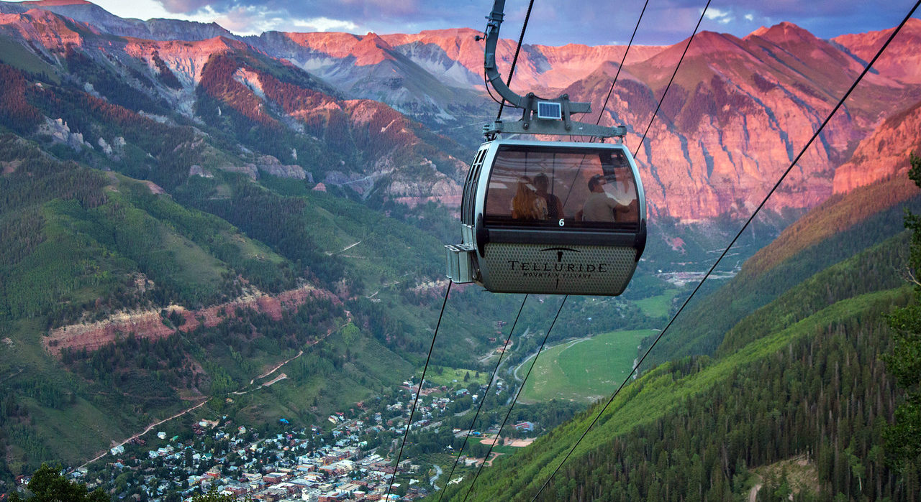
TELLURIDE Workshop: Molecular Videography
Ah Haa School for the Arts
Organizers: Eric Potma & Ara Apkarian
September 18 -21, 2018

Program

7:00 - 8:00 | Breakfast | Everyday
TUE - AM | Chair | Eric Potma
8:00 - 8:15 | Organizational
8:15 - 9:00 | Ara Apkarian (UC Irvine)
9:00 - 9:45 | Martin Wolf (Fritz Haber Institute)
9:45 - 10:15 | Break
10:15 - 11:00 | Dominik Peller (Regensburg)
11:00 - 11:45 | Emiko Kazuma (RIKEN)
11:45 - 1:00 | Lunch
TUE - PM | Chair | Ara Apkarian
1:00 - 1:45 | Markus Raschke (Colorado)
1:45 - 2:30 | Hrvoje Petek (Pittsburg)
2:30 – 3:00 | Break
3:00 - 3:45 | Niek van Hulst (ICFO)
3:45 – 5:00 | Ben Taber (UC Irvine)

WED - AM | Chair |  | Hrvoje Petek
8:00 - 8:45 | Dwayne Miller (Max Plank)
8:45 - 9:30 | Ryota Iino (IMS, Japan)
9:30 - 10:15 | Eric Potma (UC Irvine)
10:15 - 10:45 | Break
10:45 - 11:30 | Tyler L. Cocker (Michigan State)
11:30 - 12:15 | Ruqian Wu (UC Irvine)
WED - PM | Free Time
THU - AM | Chair |  | George Schatz
8:00 - 8:45 | Matt Graham (Oregon State)
8:45 - 9:30 | Joonhee Lee (UC Irvine)
9:30 - 10:15 | Lasse Jensen (Penn State)
10:15 - 10:45 | Break
10:45 - 11:30 | Peter Lu (Bowling Green)
11:30 - 12:15 | Patrick Z. El-Khoury (PNNL)
12:15 - 1:00 | Lunch
THU - PM | Chair |  | Lasse Jensen
1:00 - 1:45 | George Schatz (Northwestern)
1:45 - 2:30 | Oliver Monti (U. Arizona)
2:30 - 3:00 | Break
3:00 - 3:45 | Hiromi Okamoto (IMS, Japan)
3:45 - 4:30 | Wayne Hess (PNNL)
6:00 - | Picnic (Ah Haa School for the Arts)
Fri - AM | Chair |  | Ara Apkarian
8:30 - 11:30 | Discussion over Coffee
11:30 | Closing: What next?

